Write Java programs to create an array an initialize and print the elements.

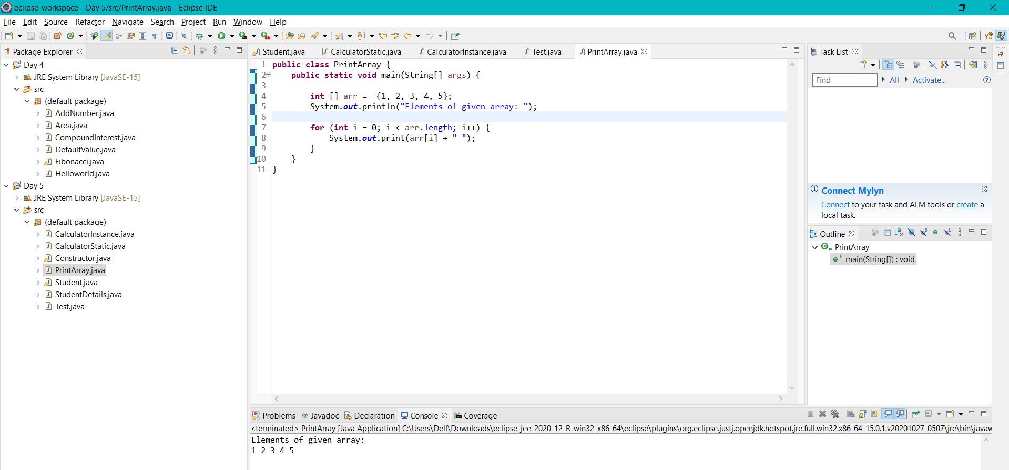

Calculate the average of numbers using Array.

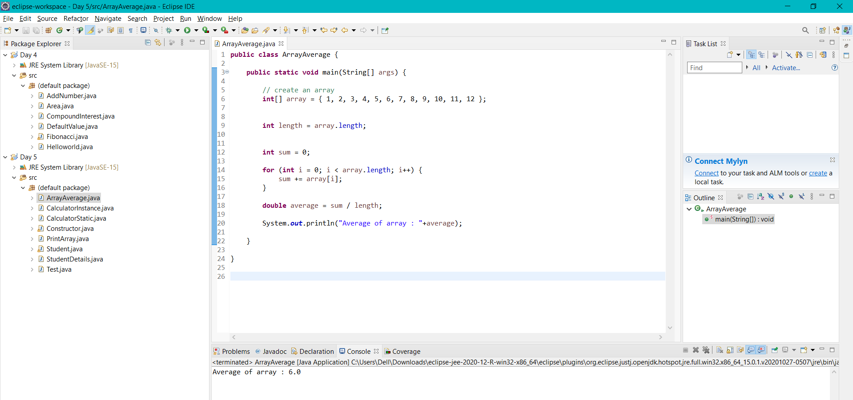

Print the array elements using for each loop.

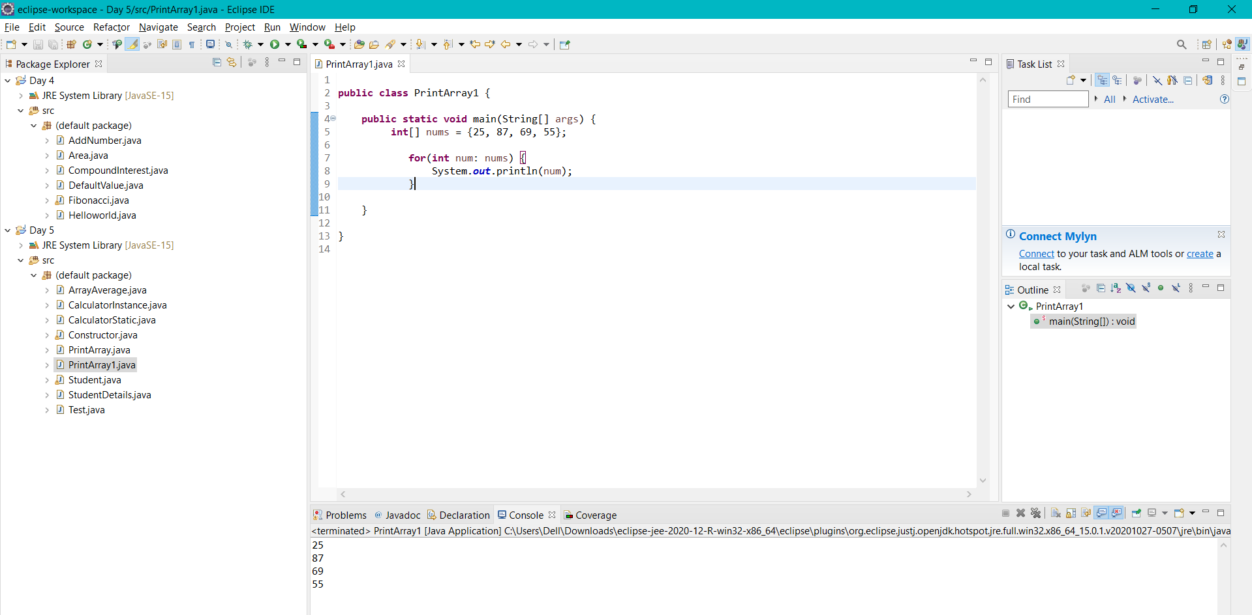

Convert char Array to String

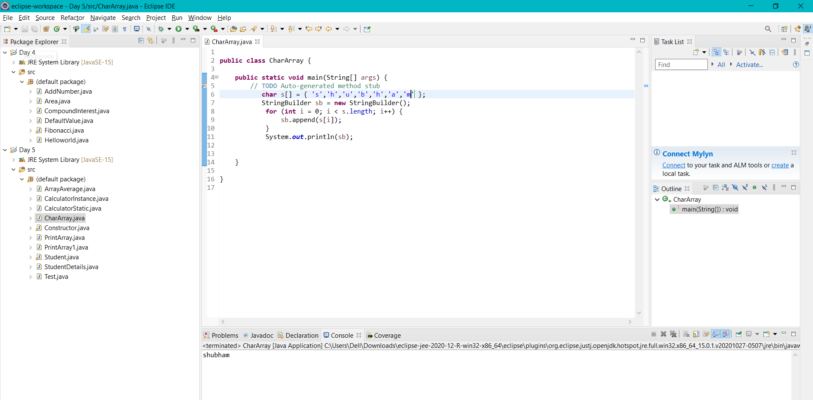

Add two Matrix using Multi-dimensional Arrays

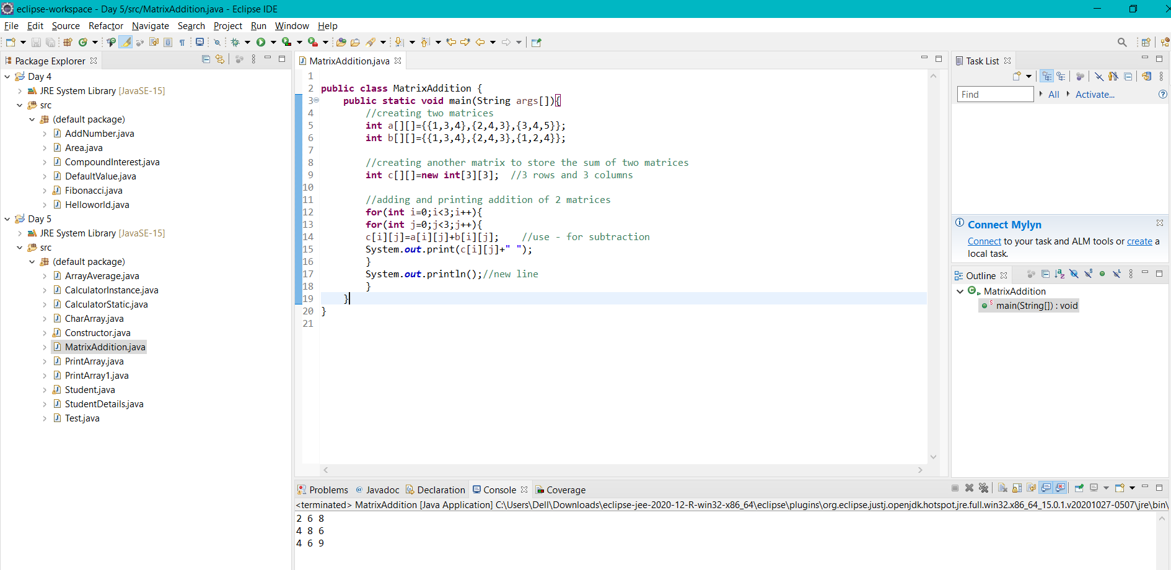

Write a java program to get the class name of array in java.

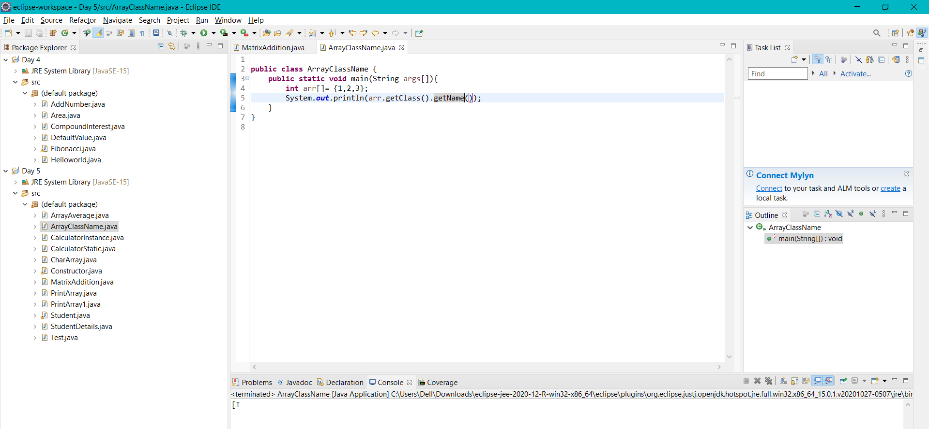

Find out the min numbers in an array.

